(Approx. 1053 words)

Wi-Fi File Transfer - Easily moves pictures from phone to computer
By Phil Sorrentino, Contributing Writer, The Computer Club, Florida
http://scccomputerclub.org
Philsorr.wordpress.com
philsorr (at) yahoo.com

Most of the pictures that most of us take with our phones remain on the phone for a very long time. It is probably because our smart phones are so convenient and easy to use to show photos: just start the App and swipe to the next photo. Our phones are always with us so we can very quickly show our friends all our latest photographically captured experiences. It may also be that there is less of a need to remove photos because our phones have such large memories. Many modern phones have 16 GB of storage. Even on a phone, with a camera with a resolution as large as 12 Mp, there is still room for many, many photos. Photos on most phone cameras are produced as .jpg files, which are compressed photo image files. The size of the resulting file is typically around 2 to 5 MB. Phones with 16 GB of memory can easily allocate 1 GB, or so, for photos. So, using as an example a large picture (5MB), you could put 200 photos in that 1 GB memory space (remember 1 GB = 1,000 MB). If you have more memory or smaller photos you could easily keep thousands of photos on that phone. Maybe you’ve been shown pictures from a phone like that, I know I have.

There are many ways of moving your pictures from your phone to your computer. “Wi-Fi File Transfer” is a free App that allows you to easily accomplish this task. (You can also use it to move files from your computer to your phone.) As with many Apps, there is also a Pro version available at a small cost. Wi-Fi File Transfer is available for both Android and Apple. You can get the Android App from the Google Play store. Before digging into Wi-Fi File Transfer, let me list some other ways to move your photos from your phone to your computer. First, you can email a photo or two to yourself as an attachment, and then collect the photos from your received email. This is only good for a few pictures because email systems have attachment size limitations. Second, if you have a microSD card slot on your phone, you could move the photos to the microSD card and then move the microSD card to your computer microSD card reader (or SD card reader with a microSD-adapter), and copy the files to the computer. Third, you could use a USB-to-microUSB cable (usually supplied with a phone or tablet) to connect the phone to your computer USB slot. The phone will show up as a device in File Explorer and you can move the photo files from the device to the computer. Fourth, you could use a USB-OTG (On-The-Go) cable to connect a Flash Memory device to your phone. Once connected, copy the files to the Flash Memory and then move the Flash Memory device to the computer USB slot and copy the files from the Flash Memory to the computer. Fifth, upload your photos to a Cloud account, such as OneDrive or Dropbox, with the appropriate App. Then download the photos from your Cloud account to your computer, using a Browser. So much for other methods, now back to Wi-Fi File Transfer.

To get going, start the App in the usual way, by touching the Wi-Fi File Transfer icon. 
Once started, the following Opening Screen will be displayed.

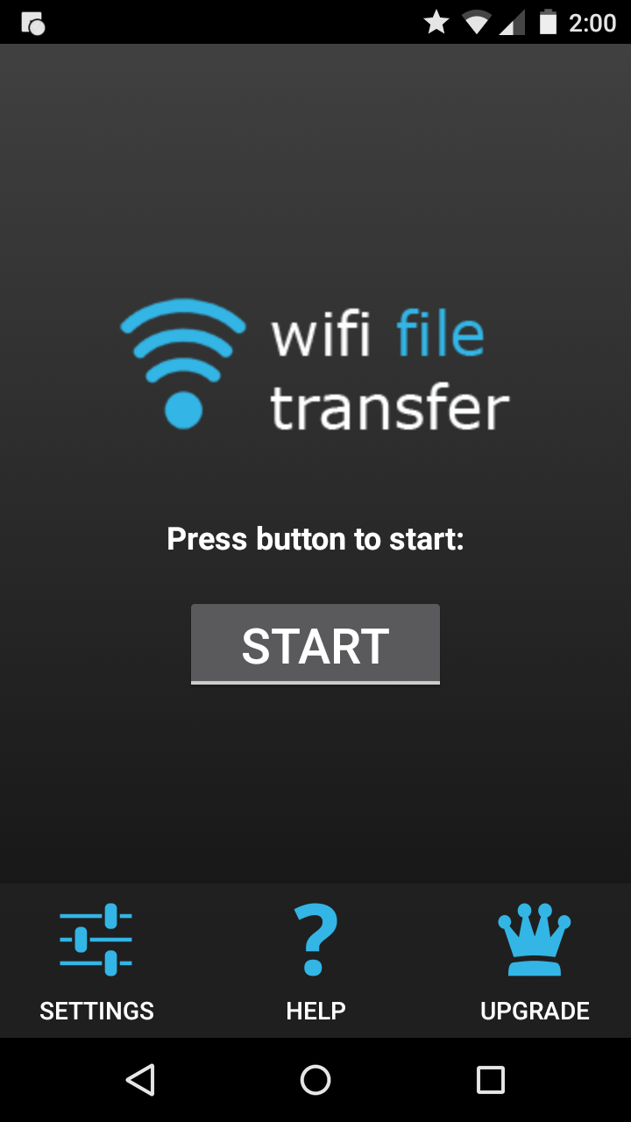 Opening Screen

Press “START” and the “IP Address” screen will be presented.

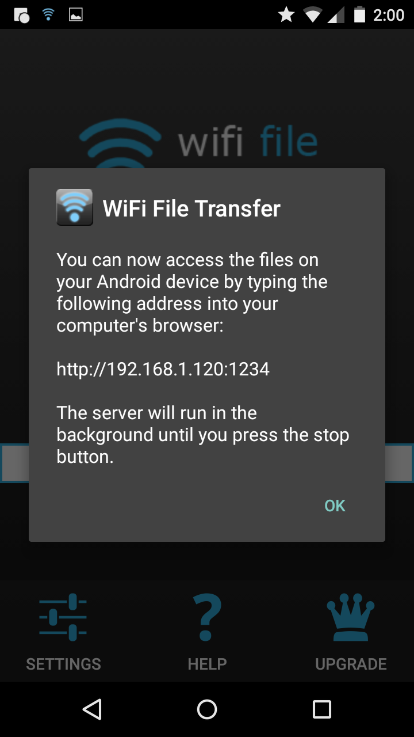 IP Address Screen

Wi-Fi File Transfer sets up a Client-Server connection, over your Wi-Fi, between your phone and your computer. (Oddly enough, in this setup, the phone is the server and the computer is the client. I point this out here, only because when it comes to moving the files, it is done using the “download” button, not an “upload” button as you might have thought.) The IP Address in the center of the screen is to be used on your computer. On your computer, start a browser, such as Internet Explorer, Chrome, or Edge. In the address bar at the top of the Browser screen, type the IP Address. In this example type “http:// 192.168.1.120:1234”, and press Enter. The browser should go to the Wi-Fi File Transfer screen. On the phone, Press “ok” on the IP Address screen.
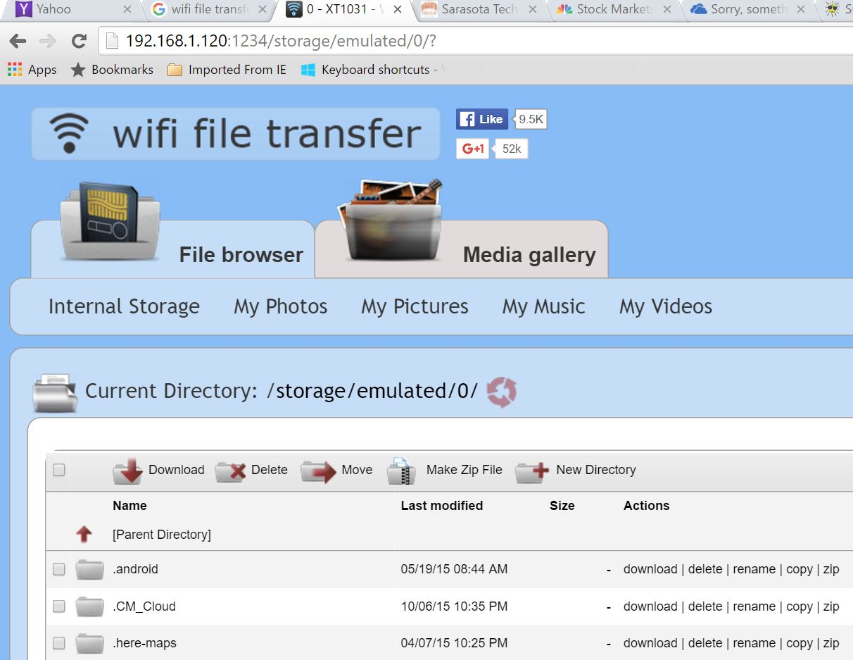 Browser Wi-Fi File Transfer Screen

Find and click “DCIM” in the list of folders (Directories). In the next screen, click “camera”, and a list of photos will be shown. The photos will probably have titles like “IMG_20160601_195876”, or something similar. The date taken is usually buried in the title, as in this example (June 1, 2016). Select the photos to be copied to the computer. (If many photos are selected you will have the option to copy them individually or all together in a Zip file. (For more than a few photos, make it easy on yourself and choose the Zip option and then unzip them on the computer, later on.) Once the photos are selected, press “Download”, and your photo(s) will be downloaded to your computer. Once the photos are downloaded, especially if you just downloaded a lot of photos, you can delete them, en masse, from the phone using “Delete”, next to “Download”. (Note that there are directions on the right side of the screen [not shown above] to allow you to “Transfer files to device”. This is essentially an Upload from the computer to the phone. Move files in this direction only if you know what you are moving and you know where to put them.) Once the transfer has completed, press “STOP” on the IP Address screen, on the phone, to terminate the client-server connection. Press ‘Back” or Home to terminate the App. Now all that is left for you to do is to Unzip the files, if they were zipped, Rename the files if desired, and put them in the appropriate location in your Pictures folder organization, and Oh by the way, back them up. So now with Wi-Fi File Transfer you should never have to fear that your pictures will be lost if you lose, or have to replace, your phone.

